Hbase installation

download the hbase package from ftp

wget ftp://192.168.1.15/bigdata/hbase-1.4.9-bin.tar.gz
tar -xvzf hbase-1.4.9-bin.tar.gz

mv hbase-1.4.9 /opt/hadoop/hbase

open .bashrc file

nano .bashrc

======add this lines======
export HBASE_HOME=/opt/hadoop/hbase
export PATH=$HBASE_HOME/bin

source .bashrc

add the line in /opt/hadoop/hbase/conf/hbase-site.xml in between <configuration></configuration>

<property>
<name>hbase.rootdir</name>
<value>hdfs://master:9000/hbase</value>
</property>
<property>
<name>hbase.cluster.distributed</name>
<value>true</value>
</property>
<property>
<name>hbase.zookeeper.property.dataDir</name>
<value>/opt/hadoop/hbase/zookeeper</value>
</property>

add the java path in /opt/hadoop/hbase/conf/hbase-env.sh

export JAVA_HOME=/usr/lib/jvm/java-8-openjdk-amd64

create the zookeeper directory manually in /opt/hadoop/hbase/zookeeper

mkdir -m 777 -p /opt/hadoop/hbase/zookeeper

restart the service in hbase before check all the services in hadoop

cd /opt/hadoop/hbase/bin
./start-hbase.sh

give jps
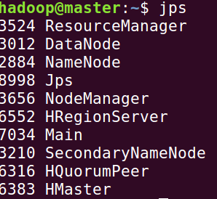

Hmaster and HregionServer is must to ensure that hbase is installed successfully.

these above services should have to run
get into hbase shell

cd /opt/hadoop/hbase/bin
./hbase shell

check the status of the connected server

by giving status

